SAT analysis and Combination boost for Collatz problem

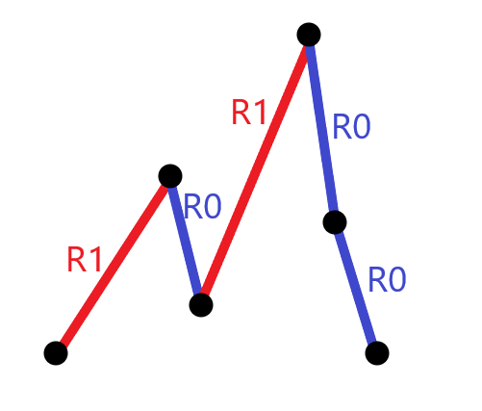

Introduction

（本文做了结构索引，建议在文档结构视图打开，这可以在结论证明之间跳转）
(This article makes a structure index, which is recommended to open in document structure view, which can jump between conclusion proofs)

我们检查了collatz猜想的数值绘图，把连接线看作两类节点（R1和R0），在高一维上分析其合理连接。
We examine the numerical plot of the collatz conjecture, consider the connection line as a node,(R1 AND R0 ) and analyze its reasonable connection in the higher dimension.

通过将计数问题转化为SAT，分析任意段C链上的组合，检验其可满足性，得到C链的解析表达式。
By converting the counting problem into SAT and analyzing the combinations on any segment C chain, the satisfiability is tested, and the analytical expression of C chain is obtained.

1，与传统技术的区别是，采用了组合分析和SAT思想以及boost归纳，先论证链条的组合可能，我们把C链的增长或减少趋势,分类为2个动作，即如图中的上山路径和下山路径，它们由任意合法长的动作组合，论证爬山的规律和下山的一般规律，得到关键的解析式。
1. The difference with traditional technology is that combination analysis, SAT thought and boost induction are adopted to demonstrate the combination possibility of chain first. We classify the growth or reduction trend of chain C into two actions, namely uphill path and downhill path as shown in the figure, which are composed of any legal long action combination to demonstrate the law of climbing and the general law of descending. Get the key analytic expression.
2， 然后在链条连接方式成立的情况下，论证它的取值范围。得到C链的爬山趋势上界
2. Then demonstrate its value range if the chain connection mode is established. The upper bound of the climbing trend of chain C is obtained
当我们发现C的合法分段是一个不定方程，存在无穷多的整数满足转折条件，所以我们暂时放弃了寻找C链的转折点，从另一个更简单的方法证明其收敛性。
When we find that the legal segmentation of C is an indefinite equation, there are infinitely many integers satisfying the turning point condition, so we temporarily give up looking for the turning point of C chain, and prove its convergence by another simpler method.
3， 根据1 2，组合得到的合法链条，结合boost技术得到C链的爬山路径有界结论，即C上任意一段入口决定了链条攀升的高度，如输入无穷大的数值，则C链无穷长，但这是不可能的，
3. According to the legal chain obtained by combination of 1 and 2, the mountain climbing path of C chain is bounded by combining boost technology, that is, any entry on C determines the height of the chain climbing. If the input value is infinite, then C chain is infinite long, but this is impossible.

如果它是有限的，那么它可能 是截止或循环的，排除了无穷上升的可能，显然地，它是循环的。
If it is finite, then it may be cutoff or cyclic, and it is argued that the chain may oscillate in intervals
我们采用逐渐加上合法连接的方法论证，证明合法的上升节点其数量会随着链条增长而减少。
We demonstrate that the number of legal ascending nodes decreases as the chain grows by gradually adding legal connections.
从而建立不存在无穷上升的链条结论。
Thus the conclusion that there is no chain of infinite ascent is established.
通过分析C链的最小生成元和合法组合，
By analyzing the minimum generator and the legal combination of C chain,
使用解析拓延，得到C链在更复杂的组合上的合法连接，
Using analytic extension, we get a legitimate connection of C chains on more complex combinations,
论证C链随着连接变长，数值必然回落。
It is demonstrated that the value of C chain must fall as the length of the connection becomes longer.
技术细节上，我们发现常规方案很难描述完整链条里的任意取样，因此采用了一些通配符技术来表达C链函数。
In terms of technical details, we find it difficult to describe arbitrary sampling in the complete chain in the conventional scheme, so we use some wildcard techniques to express C-chain functions.
--------------------------------------------------------------------------------------------------------------
快速的结论列表：

Quick list of conclusions:

C中不存在形如R1R1的组合
1, there is no combination of R1R1 in C
获得R0与R1的迁移关系图
Obtain the node diagram of the triangular relationship
2，C中，连续叠加的R0R1有界，和其解析式，证明有界
2, In, C-chain, the continuous superposition of R0R1 is bounded, and its analytic expression is proved to be bounded

3,C中，连续叠加的R1R0有界，和其解析式，证明有界
3. In C-chain, R1R0 of continuous superposition is bounded, and its analytic expression is proved to be bounded
4，C中，连续叠加的R0R0有界，和其解析式，证明有界
4,In C-chain, R0R0 of continuous superposition is bounded, and its analytic expression is proved to be bounded

5，合法的R0和R1三节点组合，其合法形式有界。
5,Legal R0 and R1 three-node combination, the legal form is bounded.

6，在三节点基础上构造连续而合法的C链，随着R0或R1的合法链接变长，R1的执行次数必然少于R0，
反证法检验 ：不存在R1比R0多的合法C链。即一个合法的C链里，输出值最终必定出现小于输入值的情况。
6, Construct a continuous and legal C chain on the basis of three nodes. As the legal link of R0 or R1 becomes longer, the execution times of R1 will be less than R0.
The proof by contradiction proves that there is no legal C chain with more R1 than R0. In a legitimate C chain, the output value must eventually be less than the input value.
则C链不是无穷增长的，只能是循环或终止。
C chain is not infinite growth, can only be a cycle or termination.
7，C中只存在3种有界连接，其合法连接也必然是有界，即C是封闭的循环。
7,There are only three kinds of bounded connections in C, and its legal connections must also be bounded, that is, C is a closed loop.

8，用结论234的合法叠加节点去组合更复杂任意长的C，也收敛，由有界性质加解析拓延方法证明。
8,By using the legal superposition nodes of conclusion 234 to combine more complex and arbitrarily long C, it also converges, which is proved by the method of bounded property plus analytic extension.

Chapter 1
Convention denote
考拉兹猜想本身声明了对于奇数和偶数有2个不同的动作规则，我们把考拉兹的约定生成规则写成2个动作标记，R0和,R1，（rule 1 and rule 2）
The Collatz conjecture itself states that there are 2 different action rules for odd and even numbers, and we write Collatz convention generation rules as 2 action flags, R0 and R1,(rule 1 and rule 2)
---------------------------------------------------
动作R0 : in是偶数，把数值in除以2得到out
R0动作写作: R0(in,out)
动作R1 : in是奇数，把数值in乘以3并且加上1得到out
R1动作写作: R1(in,out)
---------------------------------------------------
---------------------------------------------------
Action R0: in is even, divide the value in by 2 to get Out
R0 Action writing: R0(in,out)
Action R1: in is odd. Multiply the value in by 3 and add 1 to get Out
R1 action writing :R1(in,out)
---------------------------------------------------

R0(2,1)或R1(2,7) 是约定对单个节点数值的表示。
R0(2,1) or R1(2,7) is the convention's representation of the value of a single node.
对于任意可能出现的数值或动作，我们用 | 符号分隔,对于两个动作之间的链接用(,)符号，
For any possible numerical or action, we separated with a | symbol, for links between two actions with symbols (,),
并用*代替不定长的合法子链。
* is used to replace the indefinite length of the subchain.
（，）逗号用于显式地连接节点，但是动作间的逗号是非必要的。
The (,) comma is used to explicitly connect nodes, but commas between actions are not necessary.
对于恒成立的式子默认输出.T. ,反之为 .F.
If it's constant, output. T. Otherwise, it is.f.
C(*R0R0R1R0R1R0R0R1R0*) 是一个截取子链的表示，
C(*R0R0R1R0R1R0R0R1R0*) is a representation of a truncated subchain,
C(in,out)=C(R0,R1,R0)=C(2,2) 是一个子链的输入输出表示
C(in,out)=C(R0,R1,R0)=C(2,2) is the input-output representation of a subchain
C(*in*)OR C(*out*)表示当前段的输入或输出
C(*in*)OR C(*out*) represents the input or output of the current segment
|符号代表选择其中之一，同义于 【或， OR，】。

| symbols represent choose one of them, synonymous with "OR, ∨,".
C(*,R0R1,*)是C中任意位置2个节点的表示。
C(*,R0R1,*) is the representation of 2 nodes at any position in C.
对于C中任意R1与R0的组合表示为C(*,R0|R1,R0|R1,*)，
For chain C in the combination of arbitrary R1 and R0 said to C (*, R0 | R1, R0 | R1, *),
在链条C里，第n个动作(R1|R0)，
In chain C，the number N action（R1|R0）
每个动作内包含输入与输出2个变量记作R0(in,out),
Each action （R0 or R1）contains input and output two variables called R0(in,out) or R1(in,out)
in，out分别是该动作变量的顺序子变量，
in and out are the sequential subvariables of the action（R0|R1） variable,
For example
R0(4,2)表示in=4，out=2
R0(4,2) means in=4,out=2
R0(6,3) ∧ R1(3,10) => .T.
R0(4,2) ∧R1(2,7)=F
C(R0(6,3)R1(3,10)))=T
C(6,3,10)=T
C(4,2,7)=F

命题复写

Propositional copying
=======================================================
;根据猜想约定规则，对于偶数输入时，规则R0
; According to the conjecture convention rule, for even input, rule R0
C(R0) ；对于链中的R0节点，For R0 nodes in the chain

(R0(in,out))%1≡0 ； 节点数值恒为整数 The node value is always an integer

(In)%2≡0 ∧ (in/2)%1≡0 ； in必须是偶数，In has to be even

out=in/2
=> out%1≡0
=>（C(R0(in,out))/2） % 1 ≡0 ∧ C(R0)∈(1,2,3,4,,,, ∞)=>.T.
;1：对于只包含一个R0的C，它的输出恒是正整数。
; 1: For C containing only one R0, its output is always a positive integer.

=======================================================
;根据猜想，对于奇数输入时，规则R1
; By collatz conjecture, for an odd number of inputs, rule R1
C(R1) ;对于C(R1)，单个C内的R1动作
R1(in) %2 =1 ; R1动作的in 为奇数
in%2≡1，in%1≡0
out=in*3+1
=>C(R1(in，out))%2≡0 ∧ R1(in)%2≡1=>.T.
;2：对于只包含一个R1的C，它的输出恒是偶数
; 2: For C containing only one R1, its output is always even

Chapter 2

我们开始关注让C链合法的连接
We only look at legal chains

推论1
1 ，猜测，在包含了2个规则的考拉兹链中任取相邻的2节点，是否存在R1R1？
Guess, take any two adjacent nodes in a Collatz chain with two rules,
Does R1R1 exist?

根据排列组合公理，R1和R0,可以组合为4种排列
According to the axiom of permutation and combination, R1 and R0 can be combined into four permutations
R0R1|R1R1|R0R0|R1R0

考察一个链片段，C(*R1R1*)，对每个节点内部
输入和输出端分别命名为in1,out1,in2,out2.
Consider a chain fragment, C(*R1R1*), each node inside C
The input and output terminals are named in1,out1,in2,out2.

∃C(R1(in1，out1),R1(in2,out2))∧ out1=in2
R1(in1)%2≡1∧ out1=in2
=>(out1)%2=0
；out1=in2 （要连接上，则节点1的输出必须等于节点2的输入）
=> (in2)%2=0
=>(R1(in2))%2=0 ∧ (R1(in1))%2≡1 => .F.
;in2不满足(in2)%2≡1作为下一个R1的输入，
; in2 does not satisfy (in2)%2≡1 as the input of the next R1,
=> C(R1R1)= .F.
=> C(*R1R1*)=.F.
结论1:C任何位置中不允许存在 形如R1R1 的子链即C(*R1R1*)=.F.

Proof by contradiction:
If exist C(R1R1)=T
There must have an odd input X
=>（（（（X*3）+1）*3）+1）%2=0
Solve for X
There is no integer solution to X
=>C(R1R1)=F
When *=T
C(*R1R1*)=F

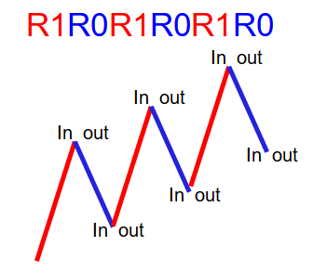
Pic 2 A path has two nodes (input, output), and a link between two legitimate paths has three nodes.）

Conclusion 1
: Subchains like R1R1 are not allowed to exist in any position of C, according to this method , Again，we have the follow:
C(R0R1)=.T.
C(R1R0)=.T.
C(R0R0)=.T.
Or writing as
When * = T
C(*R0R1*)=.T.
C(*R1R0*)=.T.
C(*R0R0*)=.T.

Or writing as
C(*R0R0*|*R0R1*|*R1R0*)=T

======================================================

2，分析子链的数值输出范围猜测2元子链中，in和out的值域。
1. Analyze the value output range of the subchain
Guess the range of in and out in a 2-element subchain.

1 :对于任意考拉兹链C(*R1R0*) ,
1: For any collatz chain C(*R1R0*)
(R1R0)%1=0
(((X*3)+1)/2)%1=0
=>X=2n+1 AND n is integer
同理，对于
C(*R0R1*)
Similarly, for C(*R0R1*)
(R0R1)%1=0,
=> (((x/2)*3)+1)%1=0
=>x=2n AND n is integer
得到主要推论：对于2元链C(*R1R0*) ,的R（in）输入值域，分别为2n+1和2n
The main corolary is obtained: for the 2-member chain C(*R1R0*), the R (in) input ranges are 2n+1 and 2n, respectively
-----------------------------------------------------------

True value table
考虑
对于每个可能的2节点的合法输入输出，
Consider For each possible 2-node legal input/output,
可以容易知道数值增长的趋势。
It's easy to see where the growth is going.
我们能用INC代表增大，DEC代表数值变小。
We can use
INC Stands for increase,
DEC Stands for decrease.
C（R0R0）=.T. DEC
C（R0R1）=.T. INC
C（R1R0）=.T. INC
C (R1R1) = .F.
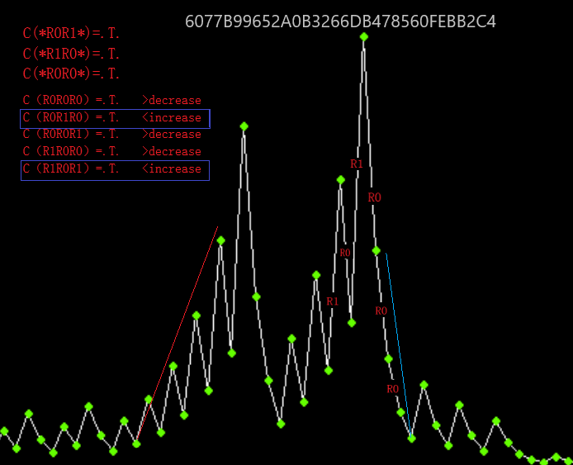
Pic3 更复杂趋势上的节点组合，总是由小的2元链接组成
根据真值表，我们可以规约为以下三角关系图像，注意，每个R节点包含了输入和输出
According to the truth table, we can specify the following triangular graph, noting that each R node contains input and output
我们在三角图上选择起点，合法的分支链接R0或R1总在相邻的方向，随着数值的合法迭代，在三角关系图(Undirected graph
)上的节点R1 或R0跳转。
We select the starting point on the trigonometric graph(Undirected graph
), and the legal branch link R0 or R1 is always in the adjacent direction. With the legal iteration of the value, the node R1 or R0 on the trigonometric graph jumps.
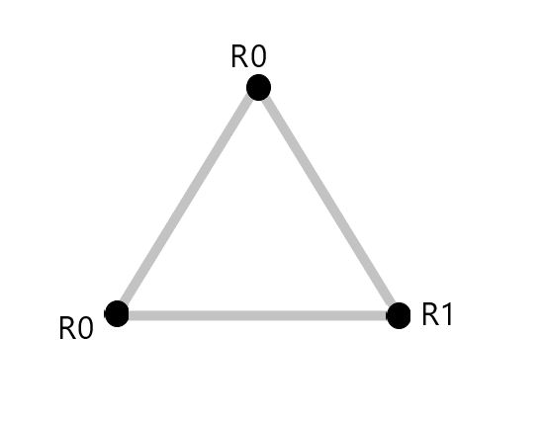

对于给定的奇数或偶数，存在2个方向的选择，从其中一个节点出发和返回，我们可以得到一条C链。
For a given odd or even number, There are two directions to go starting and returning from one of the nodes, we can get a C chain

Guess
If exist C（*INC,INC*）,true?
我们尝试重复以上组合，得到更多的R0R1R0组合，

猜测任意长度的R1R0叠加是否存在,
Guess whether R1R0 superposition of any length exists

考虑d为叠加次数，例如d=2
Consider d as the number of superpositions, for example d=2

We have C(INC,INC) = C(R1R0，R1R0)

solve ((((3X+1)/2)*3+1)/2)%2=1 and x%1=0
=>X=8n+7 AND n is integer ,

As d=3 means C(INC,INC<) = C(R1R0，R1R0，R1R0)
solve (((((((((x*3)+1)/2)*3)+1)/2)*3)+1)/2)%2=1 and x%1=0
=>x=16n+15

d=4
solve ((((((((((((x*3)+1)/2)*3)+1)/2)*3)+1)/2)*3)+1)/2)%2=1 and x%1=0
=>x=32n+31

d=5
solve (((((((((((((((x*3)+1)/2)*3)+1)/2)*3)+1)/2)*3)+1)/2)*3)+1)/2)%2=1 and x%1=0
=>x=64n+63
……
d=10
solve ((((((((((((((((((((((((((((((x*3)+1)/2)*3)+1)/2)*3)+1)/2)*3)+1)/2)*3)+1)/2)*3)+1)/2)*3)+1)/2)*3)+1)/2)*3)+1)/2)*3)+1)/2)%2=1 and x%1=0
=>x=2048n+2047

结论2
以上归纳法得到对于任意爬山链上的R1R0迭代，d次叠加的合法链，

Conclusion 2
According to the above induction method, for R1R0 iteration on any mountain climbing chain, the legal chain of d superposition,

∀C(*R1R0*)=T
其输入必须满足
Its input must be satisfied
R1(in)=(（2*2^d）*n)+(2^d-1)
n%1=0 and d%1=0
这里，X代表当前截取段的合法输入数值，
n是当前段在Y轴的相对高度
d是当前段C链的R1R0迭代次数
Here, X represents the valid input value of the current truncated segment,
n is the relative height of the current segment on the Y-axis
d is the number of R1R0 iterations of the current segment C chain

同理，对于奇数输入的C链，考虑任意叠加的R0R1
Similarly, for a C chain with an odd number of inputs, consider any superposition of R0R1
对于c(*R0R1*)的d次叠加
d superposition of c(*R0R1*)

D=1;C(R0R1)
solve (((x/2)*3)+1)%2=1 and x%1=0
=>x=4n
D=2; C(R0R1R0R1）
solve ((((((x/2)*3)+1)/2)*3)+1)%2=1 and x%1=0
=>x=8n+2
D=3
solve (((((((((x/2)*3)+1)/2)*3)+1)/2)*3)+1)%2=1 and x%1=0
=> x=16n+6
D=4
solve ((((((((((((x/2)*3)+1)/2)*3)+1)/2)*3)+1)/2)*3)+1)%2=1 and x%1=0
=>x=32n+14
D=5
solve (((((((((((((((x/2)*3)+1)/2)*3)+1)/2)*3)+1)/2)*3)+1)/2)*3)+1)%2=1 and x%1=0
=>x=64n+30

根据以上归纳得到 对于d次迭代的R0R1爬山链，
According to the above

Conclusion 3
According to the above induction, R0R1 mountain climbing chain of d iterations can be obtained.

∀C(*R0R1*)=T
输入要满足
The input needs to satisfy
R0(in)=((2*2^d)*n)+2^d-2）
n%1=0 and d%1=0

d是R1R0迭代的次数。n常数决定了C(*in*)的爬山起始高度,即y轴系数

d is the number of iterations R1R0. The n constant determines the initial climbing height of C(*in*), which is the Y-axis coefficient

Chapter 3

结论4
根据结论2和3的方法，还可以推导下山趋势得到解析式。
在此命题和证明部分里，仅仅需要知道它有上下界，即可满足后续组合推导。

Conclusion 4
According to the methods in Conclusion 2 and 3, the downhill trend can be derived to get the analytical expression.
In this part of the proposition and proof, it is only necessary to know that it has upper and lower bounds to satisfy subsequent combinatorial derivation
依照上文使用的方法，同样知道
According to the method (in conclusion 2,3,) used above, also know
∀C(*R0R0*)=T,THEN
C(in)=n*2^d and n%1=0 k%1=0
d is the number of superpositions
and n is the relative height of c (in) on the Y-axis

结论5

Conclusion 5
多个R0R1组合的 booster论证
从以上1，2，3，4结论，可以组合分析得到推论5
根据结论1 C任何位置中不存在 形如R1R1 的子链
对于任意位置的C链取出2规则，他们只能是R0R0 ,R1R0,R0R1
三种之一。（对于任意长的考拉兹链在其中任取2节点组成的二元子链，它的可能排列只有3种 :R0R0,R1R0,R0R1
C(*R1R0*)|C(*R0R1*)|C(*R0R0*)=T

Conclusion 5
Chapter 3 booster Demonstration of multiple R0R1 Combinations
From the conclusions 1, 2, 3, and 4 above, we can combine the analysis to get Inference 5
C does not have a subchain of the form R1R1 in any position
For any C chain at any position, take out rule 2, they can only be R0R0,R1R0,R0R1
One of three. (There are only three possible permutations for any 2-node binary subchain of any long Collatz chain :R0R0,R1R0,R0R1
C(*R1R0*)|C(*R0R1*)|C(*R0R0*)=T

------------------------------------------------------------------------------
对于3个节点可能的组合里，其中根据推论1
For any possible combination of 3 nodes, where we have corollary 1
C(R1R1)=.F.
C(R0R1R1|R1R1R0|R1R1R1)= .F.

附加的3节点合法性推导
对任意合法C链中三节点的性质分析
Additional 3-node legitimacy derivation
The property analysis of three nodes in any legitimate C chain

----------------------------------------
∀C(*R0R1R0*)=T,
C(*in*)%2=0 and
C(*out*)=(((x/2)*3+1)/2) AND out%1=0
=>
=>x=4n+2 ,n is integer
----------------------------------------
∀C(*R1R0R1*)=T
C(*out*)=((3X+1)/2)*3+1 AND out%1=0
=>
=>x=4n+3 AND ,n is integer

----------------------------------------
∀ C(*R0R0R1*)=T
C(*out*)=(x/4*3+1)AND out%1=0
=>
=>x=4n AND n is integer

----------------------------------------
∀ C(*R1R0R0*)=T
C(*out*)=(x/4) AND out%1=0
=>x=4n+1 AND ,n is integer
以上是对于任取C中三节点的输出的值域
This is the range for the output of any three nodes in C
==========================================================

Chepter 4
C链增长时，R1的数量趋势
;根据chapter3 3节点合法性的证明
; Proof of the validity of 3 nodes according to chapter3
=>
C(R0R0R0|R0R1R0|R0R0R1|R1R0R0|R1ROR1) =T
C（R0R0R0）=.T.
C（R0R1R0）=.T.
C（R0R0R1）=.T.
C（R1R0R0）=.T.
C（R1R0R1）=.T.
考虑“，”是一个连接符，也可以写作
Consider that ", "is a concatenator, which can also be written
C（R0R0,R0）=.T.
C（R0R1,R0）=.T.
C（R0R0,R1）=.T.
C（R1R0,R0）=.T.
C（R1R0,R1）=.T.
对于每个可能的3节点的合法输入输出，可以容易知道数值增长的趋势。
For each possible 3-node legal input and output, it is easy to know the trend of value growth
我们能用 inc 代表增大，dec 代表数值变小。
We can use
(INC) Stands for increase,
(DEC) means the value gets smaller.
C（R0R0R0）=.T. DEC
C（R0R1R0）=.T. INC
C（R0R0R1）=.T. DEC
C（R1R0R0）=.T. DEC
C（R1R0R1）=.T. INC
现在，我们考虑四节点的连接，下图0，1代表了R0,R1的简化
Now, let's consider a four-node connection. Figure 0,1 represents a simplification of R0,R1
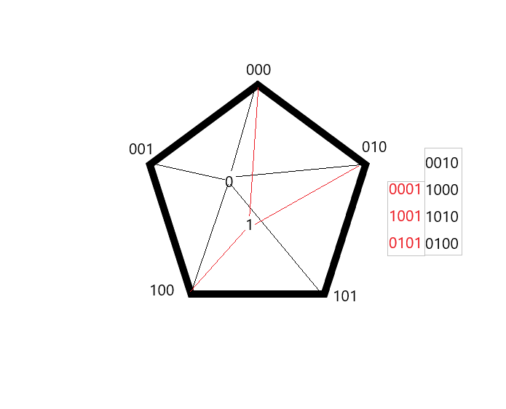
C(0001)=T
C(1001)=T
C(0101)=T
C(0010)=T
C(1000)=T
C(1010)=T
C(0100)=T

C(1011)=F
C(0011)=F.

--------------------------------------------------------------------------------------------------------
考虑5节点的连接
Consider a 5-node connection

选择4节点C链中合法的链接
Select the valid link in the 4 nodes

为它们分别加上0，或1的合法连接，同样地根据结论1及以上
Add a legal connection of 0 or 1 to each of them, again according to conclusion 1 and above

IF C(*)=T
C(00010|10010|01010)=T AND C（00100|10000|10100|01000）=T
C(00011|10011|01011)=F AND C（00101|10001|10101|01001）=T

在数列增长到5节点的合法连接时,新增了3个的非法链接，
When the list grew to five legitimate links, three illegal links were added,

在剩余的合法连接里，我们已经观察到0的数量开始比1多。
As the sequence grows to a legal connection of five nodes, we have observed that zeros begin to outnumber ones.

我们可以把这个方法不断重复，推广到足够长的链条。
We can repeat this method over and over again to a long enough chain.

显然地，统计一个合法的C（*）中所包含R1的数量决定了数列的上升趋势。
Obviously, the number of R1's determines the upward trend of the sequence.

Conclusion 6
结论6在每个截取的单调上升链C(*R1|R0,R1|R0*)里，R1,R0的数量均等。
Conclusion 6 at each intercepting monotonically chain C (* R1 | R0, R1 | R0 *), R1, an equal number of R0.
在每个下降的链条里，R0要比R1多。这表明随着合法链条的增长，R0的数量将会多于R1。
The amount of action R1 will be less than that of action R0
反证法
Proof by contradiction

在结论4已经证明了不存在无穷攀升的且连续叠加的C链，
假设存在R1比R0多的连接，真？
In conclusion 4 has proved that there is no endlessly climbing and continuously superimposed C chain,
Suppose there are more R1 connections than R0. True?

如果存在，则R1比R0多，
但是，无法找到不包含R1R1连接的合法C链，同时R1比R0多。
可见假设不成立。

If there is, R1 is more than R0, but it is impossible to find a legitimate C chain that does not contain R1R1 connections, and R1 is more than R0. So the hypothesis is not valid.
即不存在R1数量比R0多的合法C链
That is, there is no legitimate C chain with more R1 than R0

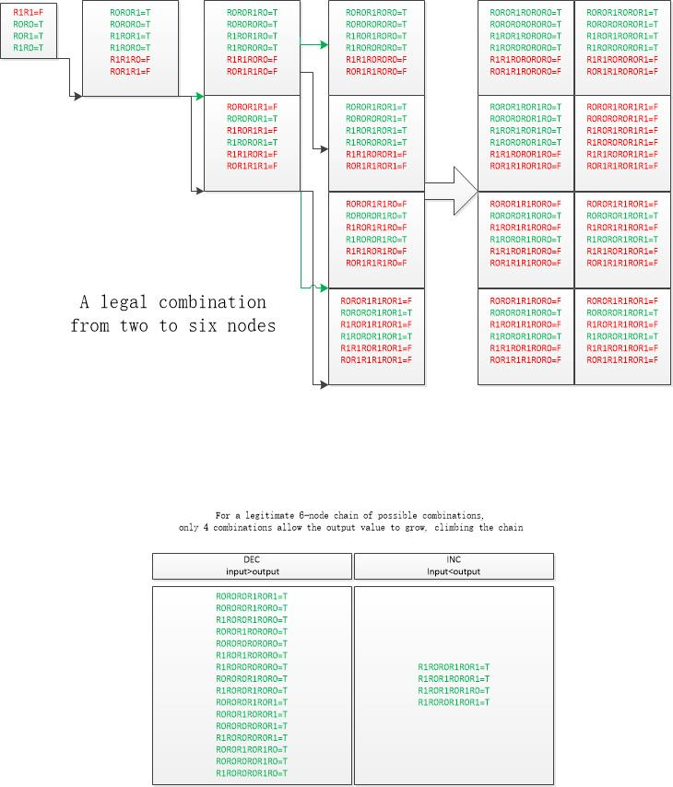

Conclusion 7
下面是最关键的解析拓延
Here is the most critical analytic extension

奇迹来了The miracle came

把合法的C增长记作INC 下降记作DEC
根据CHAPTER 4论证，
Let's call the legal C increase INC and the legal C decrease DEC
According to the argument in CHAPTER 4,

C（R0R0R0）=.T. DEC
C（R0R0R1）=.T. DEC
C（R1R0R0）=.T. DEC

C（R1R0R1）=.T. INC
C（R0R1R0）=.T. INC

IF EXIST C(INC,INC) TRUE?

C(R1R0R1,R1R0R1)=F
AND
C(R1R0R1,R0R1R0)=T INC
C(R0R1R0,R0R1R0)=T DEC

显然地，通过三节点组合的INC，其合法的C链分叉了一条下降的路径。
Clearly, the legal C chain forks a descending path through a three-node combination of INC.
我们不做更复杂的组合，这显然是可以推广到更复杂的长连接的，
Instead of doing more complicated combinations, which obviously can be generalized to more complicated long connections,

已知一个合法的C链We have a legitimate C chain

∀ C(*)=T AND C(*)=C(*R1*R0*)%1=0

C(*inc*dec*) =T OR C(*dec*inc*)=T

替换掉inc 为R1,替换掉dec为R0，
Replace inc with R1, replace dec with R0,
We have
C(*R0*R1*|*R1*R0*)=T

仍然返回到结论1，2，3，4，5，6，7
It still go back to conclusion 1,2,3,4,5,6,7

=>得到关系图Get a graph
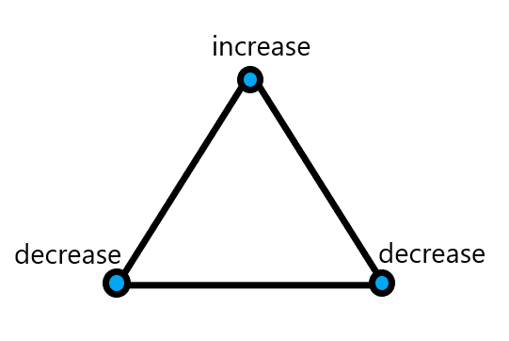
=

Conclusion 8
结论8 有界函数C（*）的连接仍然是有界函数，显然C链收敛。
The concatenation of a bounded function C(*)is still a bounded function, and clearly the C chain converges.

Chapter 5
总结论
本文章没有分析C链的极限高度，但是我们可以证明得到C链转折。
没有分析C链的循环次数，但是我们可以证明得到C链不会无穷增长，从而只剩下转折和循环两个趋势。

General conclusion
The ultimate height of C chain is not analyzed in this paper, but we can prove that C chain transition is obtained.
We did not analyze the number of cycles of the C chain, but we can prove that the C chain does not grow indefinitely, leaving only the two trends of turning and cycling.
.
本文章使用的C链定义符号系统，适合精简地分析此类问题。这值得推广。
我们在细节上可能跳过了大量的运算，但是你可以明显地看到它是可行的。

The C chain definition symbol system used in this paper is suitable for the concise analysis of such problems. This is worth promoting.
We may have skipped a lot of math on the details, but you can clearly see that it works.

方法论
本文使用了归纳法得到关键支撑，排除法得到分析方向，用反证法再次确认方向，用力迫法推导合理连接，然后用嵌入与迭代的思路构造全链条，从而构造证明。

methodology
In this paper, induction method is used to get the key support, elimination method to get the analysis direction, use the antithesis method to confirm the direction again, force method to deduce the reasonable connection, and then use the idea of embedding and iteration to construct the whole chain, so as to construct the proof.

我们用组合的方法论证了，考拉兹链条的逻辑构造，，每一个考拉兹链条可以分为上山链条和下山链条两种，而连续组合考拉兹链条的上山图形是一种锯齿状，

